Data Sheet
Product Information
Product Name | : | Recombinant Human Vascular endothelial growth factor 165 (rhVEGF165)
Synonyms | : | VEGF, vascular permeability factor (VPF)
Description | : | The protein is a signal protein produced by cells that stimulates vasculogenesis and angiogenesis. It is part of the system that restores the oxygen supply to tissues when blood circulation is inadequate. VEGF's normal function is to create new blood vessels during embryonic development, new blood vessels after injury, muscle following exercise, and neaw vessels (collateral circulation) to bypass blocked vessels. When VEGF is overexpressed, it can contribute to disease. Solid cancers cannot grow beyond a limited size without an adequate blood supply; cancers that can express VEGF are able to grow and metastasize. (Ref. From Wikipedia)
NCBI Accession No. |  | NM_001171626.1
Amino acid sequence | : | MAPMAEGGGQNHHEVVKFMDVYQRSYCHPIETLVDIFQEYPDEIEYIFKPSCVPLMRCGGCCNDEGLECVPTEESNITMQIMRIKPHQGQHIGEMSFLQHNKCECRPKKDRARQENPCGPCSERRKHLFVQDPQTCKCSCKNTDSRCKARQLELNERTCRCDKPRR*
Molecular Mass | : | 19.26 kDa (167 aa)
Protein Tags | : | No tagging
Source | : | E. coli.
Cat. No. | : | JW-H014-0010, JW-H014-0025, JW-H014-0050, JW-H014-0100, JW-H014-0250, JW-H014-0500, JW-H014-1000
Storage | : | Should be at ≤ -70 ℃ as undiluted aliquots of handy size. Avoid repeated freezing and thawing.
Cross Reactivity | : | Human, Mouse, Pig, Rabbit, Rat, Sheep, Chicken

Quality Control
Test items |  | Specifications
Appearance | : | Clear, colorless liquid
Purity | : | Greater than 98 % by RP-HPLC and SDS-PAGE
Specificity | : | Using Western blot, detection | 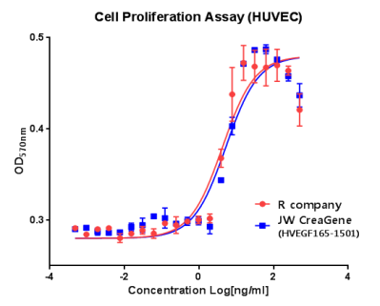
Concentration | : | 0.1 mg/㎖, Bradford method
Biological Activity | : | Determined by proliferation of HUVEC indicator cells.  The ED50 is < 6.0ng/ml, corresponding to a specific activity of <1.6 × 10⁵ U/mg
Endotoxin | : | Less than 0.2 EU/㎍ as determined by the LAL method
Formulation | : | PBS, 5% glycerol (pH 8.0) without preservative or carrier proteins.
Stability | : | Stable for up to 12 months at -70 ℃. Stable for a month at 4 ℃.
Sterility | : | Sterilized through a 0.2 ㎛ membrane filter and packaged aseptically. Culture for 2 weeks, no growth

